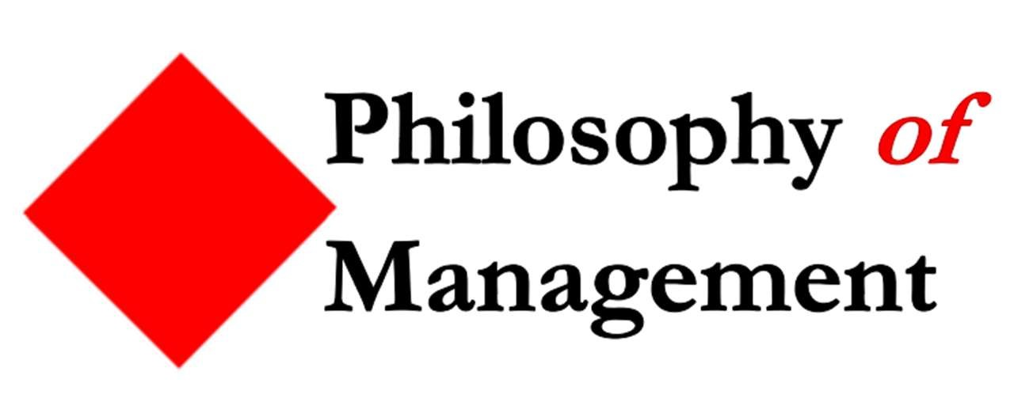
16th Philosophy of Management Annual Conference June 21-24, 2024 (EM Normandie, Oxford, UK)
Call for Submissions:

The 16th edition of the Philosophy of Management Annual Conference will be held in Oxford, UK at the EM Normandie Oxford Campus, on 21-24 June 2024. As usual, it guarantees a 45-minute slot for each paper, for an unhurried presentation and in-depth discussion.

GENERAL TRACK
We welcome submissions that explore all angles of management in private or public organizations through a philosophical lens: e.g., applied ethics; social, moral and political philosophy; ontology; epistemology; axiology; aesthetics. In any of these areas, we encourage scholars to propose novel, critical, timely and/or controversial arguments. Submissions can also adopt a ‘meta-’ standpoint for raising and answering questions such as “What is philosophy of management?” “Is philosophy useful for managers?” “Is management a science or an art?” “Can management be part of the humanities and, if not, what else should it be part of?” We are looking forward to receiving your submissions by 31 January 2024.

SPECIAL TRACKS
The Conference is associated with the journal Philosophy of Management( https://www.springer.com/journal/40926 ) and, in addition to the general track, will host two special tracks for papers aiming to be submitted after the conference to one of the incoming special issues of this journal. If submitting for one of these special tracks, please mention it in the title of your paper.
Special Track: Rethinking Leadership
Most of the academic work on leadership is conducted by social scientists, who frequently lament the lack of an agreed-upon definition of their subject matter and who often complain about conceptual confusions. Philosophers are in a position to make meaningful contributions to the conceptual clarification of leadership and its related notions. Here are some suggested areas of conceptual and normative inquiry. Is it possible to define the concept of leadership as employed by practitioners and scholars? How are we to understand the traditional lineup of “leadership theories”—are they about the same thing, and are they actually competitors? In what sense is the concept of “distributed” or shared leadership to be considered to be leadership at all, if everyone has the same level of influence and responsibility? Is leadership essentially normative, given that guiding a group in just any direction—as effectively as you like—does not alone seem to be a sufficient criterion of good leadership? What can social ontology tell us about leadership, given that the notion of leadership is so embedded in other social constructed ideas, such as organizations, resources, directions, rights, and responsibilities? Is leadership an appropriate topic for scientific inquiry? What can we learn from philosophers who have directly addressed leadership, such as Confucius, Laozi,
Kautilya, Plato, Seneca, or Machiavelli?

Special Track: The AI Awakening
The Center for Artificial Intelligence (AI) Safety recently released a statement that “Mitigating the risk of extinction from AI should be a global priority alongside other societal-scale risks such as pandemics and nuclear war”. The statement was signed and endorsed by prominent figures within the AI community, including executives from OpenAI, DeepMind, and Anthropic, in addition to researchers across the globe. Unsurprisingly, the fear of extinction has caught the attention of media worldwide, painting the emergence of AI as an “existential threat”. Indeed, AI poses an immediate danger to our relationship with the world, our place in it, and the values we constitute. One glaring illustration of this is the exploitation of our personal data for profit maximization, often at the cost of our autonomy, human agency, and democratic foundations. At the same time, AI can also be considered a progressive technology which promotes plurality, empowers citizens, and serves the public good. This brings us to an opportune moment to delve into the philosophical aspects surrounding the management of AI and contemplate the roles that both private enterprises and governments can and ought to assume in this evolving landscape.
This special track delves into fundamental questions surrounding the management of AI, its implications, and its place in the broader context of human existence. We welcome submissions focusing on ethical, political, and social dilemmas concerning the development and deployment of AI systems, including issues related to privacy, bias, and the impact of automation on society. We also invite scholars to engage with the topic from diverse non-normative perspectives, such as epistemology, ontology, and aesthetics. This philosophical inquiry does not only seek to understand the limitations and possibilities of AI but also challenges us to reflect on the nature of our own humanity in a world increasingly intertwined with this technology.

Submission process
- The submission should be a short paper (approximatively 1,500 words) setting out the question, approach, and main lines of argument.
- The short paper should be anonymized and submitted online at https://www.editorialmanager.com/phom/default2.aspx

- STEP 1 when prompted to “Select article type” you should select “ORIGINAL RESEARCH”
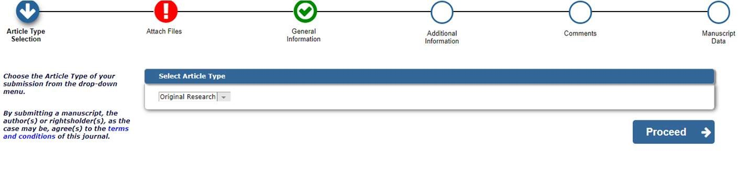
STEP 2 When asked: “Does this manuscript belong to a special issue?”, please select “YES”.
Then select “SI: PHILOSOPHY OF MANAGEMENT ANNUAL CONFERENCE” and complete the submission process until you receive the email confirmation.
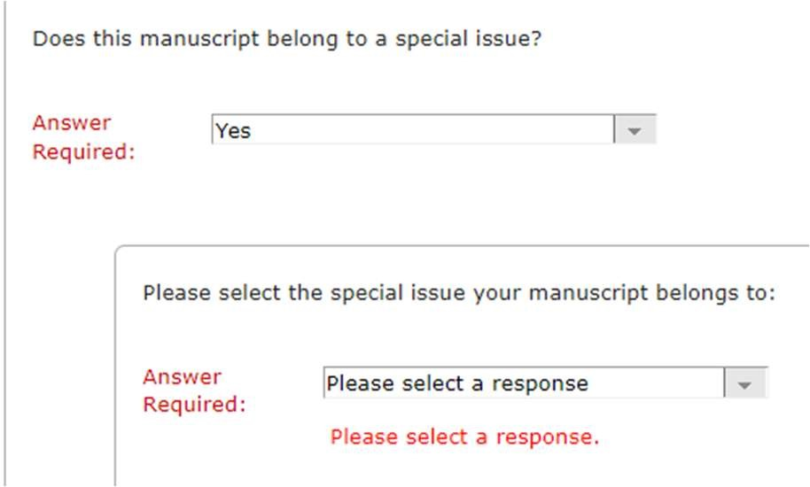
- Submissions to one of the Special Tracks should mention the respective special track name in the paper title.
- If you encounter difficulties in uploading your paper or if you have any query about the call, the submission process, the venue or the conference please contact Marian Eabrasu at < meabrasu@em-normandie.fr >

Key dates:
- Deadline for short paper/extended abstract submission: 31 January 2024
- Notification of acceptance: 28 February 2024
- Conference: 21-24 June 2024

Additional information about the conference:
- The venue is the Jericho Building on the City of Oxford College premises.
- Fee estimates 250 £ including conference registration and catering.
- The program of the PHOM 2023 conference:
https://www.em-normandie.com/sites/default/files/medias/documents/PHOM2023_final_v2.pdf

Conference Committee:
Marian Eabrasu (chair) (EM Normandie, Business School) < meabrasu@em-normandie.fr >

David C. Bauman (Regis University)
Minjie Cai (Greenwich University)
Alicia Hennig (Technical University Dresden)
Nigel Laurie (London Facilitators, UK; former Royal Holloway, University of London)
Alan Morrison (Said Business School, University of Oxford)
Cristina Neesham (Newcastle University)
Robert Phillips (York University)
Lucien von Schomberg (Greenwich University)
Wim Vandekerckhove (EDHEC Business School)
Pat Werhane (De Paul University and University of Virginia)
David Carl Wilson (Webster University)

